1) Name of Seminar: ORIENTATION SESSION ON SSIP POLICY AND INNOVATION SSIP CELL-AARAMBH (SSIP 2.0)
2) Date of seminar: 13/09/2022
3) Time: 11:00 am to 12:30 pm
4) Name of Expert: Prof. (Dr.) N J Dalal & Prof. Anjum M. Mirza

5) Name of Coordinator: Prof A M Mirza
6) Designation of Coordinator: Assistant Professor
7) Email ID: anjummirza@ldce.ac.in
8) Mobile No: 9033923017
9) Number of Participants: 52
10) Registration Link: off –line mode
11) Expert contact No. : 9033923017
12) Expert email ID: anjummirza@ldce.ac.in
13) Expert’s Designation and college name: Assistant Professor, L D COLLEGE AHMEDABD
14) Photo graphs of Seminar:
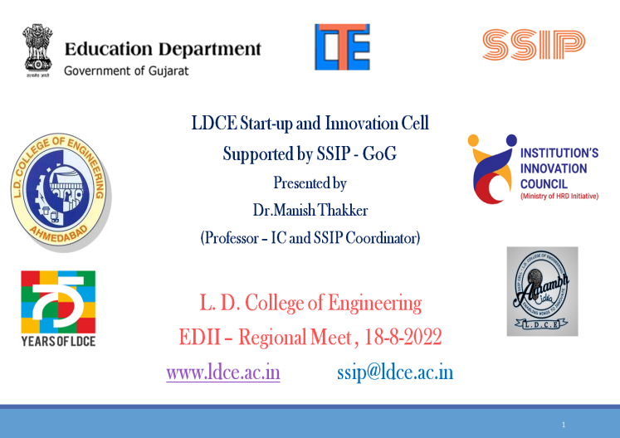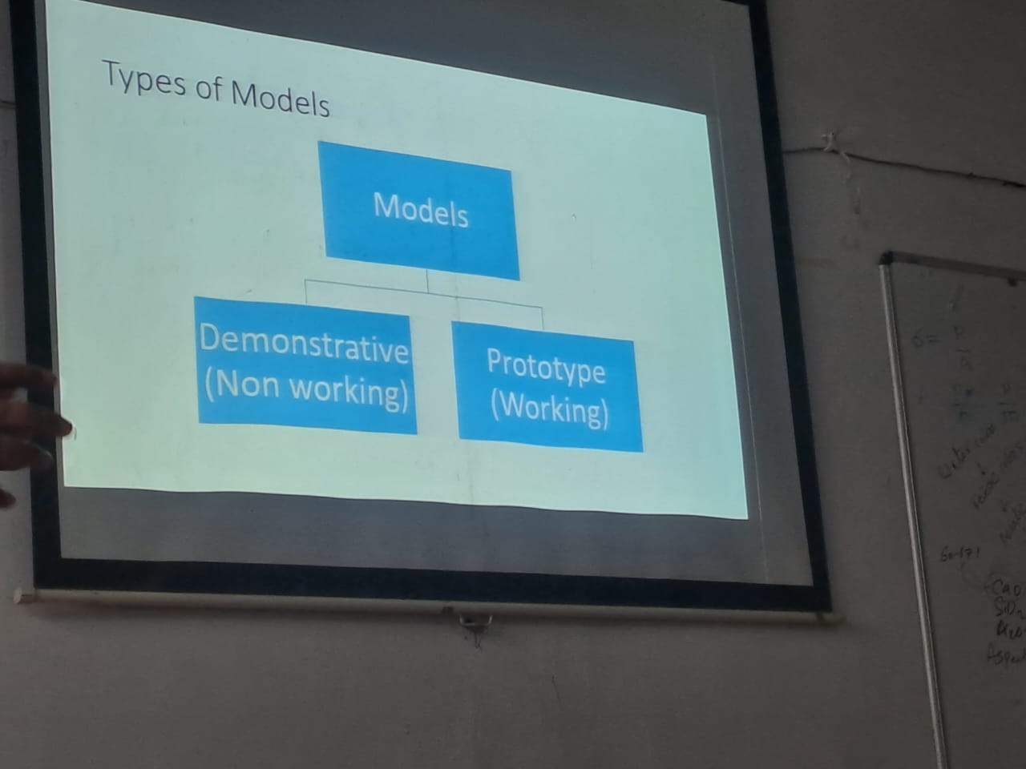
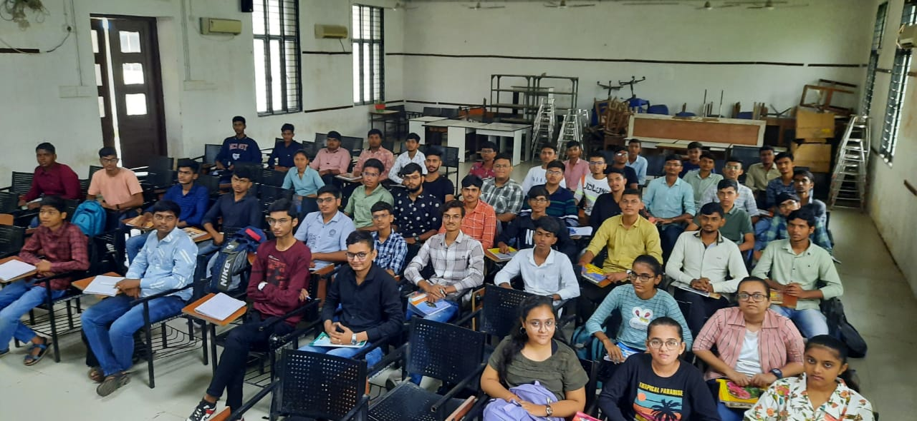
15) Venue: LD college Ahmedabad (Vishveshvaraya Hall)

